**Exhibit “B”:**

**Rudder Pointe Subdivision - Development Standards**

**Development requirements for Planned Development – Mixed Use District (PD-M), hereinafter also referred to as “Rudder Pointe PD” or "the District" or "this District ", allowing certain residential, office and retail uses on 42.1 acres of land out of Stephen F. Austin League #10 adjoining the northwest side of the existing Rudder Pointe Subdivision in Bryan, Brazos County, Texas**

**SECTION 1: General Purpose and Description**

The intent of this development plan is to guide planning of land use and physical development on the subject property. This development plan is envisioned as a tool to help stabilize and improve property utilization, to facilitate appropriate use of the property in the community interest, ensure protection of surrounding properties from foreseeable negative impacts resulting from permitted uses, to strengthen the area economy and to promote the general welfare of the community.

**SECTION 2: Definitions**

Terms that are not expressly defined below shall have the meanings set forth in the City of Bryan Code of Ordinances. Terms not defined in either this Rudder Pointe PD or the City of Bryan Code of Ordinances shall have their ordinary dictionary meanings, based on the latest edition of Merriam-Webster’s Unabridged Dictionary.

The term “permitted” shall mean all uses permitted by right within the zoning classification specified, as well as other uses defined and described in the Zoning Ordinance of the City of Bryan as being permitted with approval of a Conditional Use Permit. Said uses permitted with approval of a Conditional Use Permit shall be subject to development review procedures of the City of Bryan Zoning Ordinance described for Conditional Use Permits.

*Detached single-family dwelling -* In this specific context, the term “detached single-family dwelling” shall mean a detached building having accommodations for and occupied by not more than one family or housekeeping unit, and which occupies a lot or tract of land on which no other dwelling unit (except an accessory dwelling where allowed with prior approval of a Conditional Use Permit from the Planning and Zoning Commission) is situated.

*Family -* In this specific context, the term “family” shall mean any number of individuals living together in a single dwelling unit; provided all such individuals except one shall be related by blood, marriage or adoption within the second degree of relationship. Foster children residing in licensed foster care homes shall not be included in the calculation of the number of unrelated individuals living together in a single dwelling unit. Licensed foster care homes shall comply with any state mandated restrictions on the number of children permitted to reside in the dwelling unit.

*Twin-home* - shall mean a dwelling comprising two single-family dwelling units on individual, fee-ownership lots, joined vertically by a party wall at the common property line, with each unit having its own front and rear entrances, front and rear yards, and a side yard on one side of the lots.

*Monument sign* - shall mean a freestanding sign that is detached from a building and having a support structure that is a solid-appearing base constructed of a permanent material, such as metal, stone, concrete block or brick.

*Pedestrian-level lighting* - means lights along driveways or streets that primarily function to illuminate pedestrian areas such as sidewalks. Typically pedestrian-level lights are pole-mounted fixtures less than 18 feet tall that are part of a secondary lighting system that helps define a positive urban character and supports nighttime activities. Because the quality of visual information is critical for traffic safety and pedestrian safety and security, pedestrian level lighting should be designed not only for vehicular traffic on driveways and streets, but also for pedestrians on sidewalks and pedestrian paths. Light fixtures should be spaced with regard to trees and other street furnishings as part of a coherent and complete streetscape design. The impact of glare should be mitigated by selecting proper optical design

*Pole mounted sign* means a freestanding sign in excess of six (6) feet in height that is detached from a building and is supported by one or more structural elements that are either: (a) architecturally dissimilar to the design of the sign; or (b) less than 50% the width of the sign face.

**SECTION 3: Land Use**

The following specific range of land uses shall be permitted by right:

* Accessory structures;
* Detached dwelling units with no more than two un-related persons;
* Country club or golf course;
* Essential municipal uses;
* Group home/community home;
* Government (federal or state) owned structures, facilities, and uses;
* Home occupations;
* Temporary structures for uses incidental to construction work on the/ premises, which said

buildings shall be removed upon the completion or abandonment of construction work;

The following uses shall be also permitted by right if used in a manner compatible with adjacent areas and on lots particularly specified for such a use on an approved plat and where applicable shall be subject to the corresponding supplemental regulations;

* Patio home (zero lot line dwelling);
* Townhouses;
* Twin-homes;

Uses Permitted Only with Prior Approval of a Conditional Use Permit from the Planning and Zoning Commission:

* Accessory dwelling unit;
* Personal care homes.

**Section 4: Physical Development**

The physical form of residential development shall comply with the development standards and limitations of the City of Bryan Code of Ordinances that generally apply to properties zoned Residential District-5000 (RD-5), subject to any modifications specified herein. Those development standards and limitations include, but are not limited to, regulations concerning density, lot area, lot width, lot depth, yard depth and widths, building height, building elevations, coverage, floor area ratio, parking, access, screening, landscaping, accessory buildings, signs, and lighting.

The following additional standards shall be applicable to the physical development:

1. Street Lighting

A decorative community street light standard including pedestrian-level lighting shall be used throughout Rudder Pointe. The specifications for the street light standard will be coordinated with, and approved by, Bryan Texas Utilities.

1. Neighborhood Walkway and Park System

The park system improvements described below shall be in lieu of ordinary parkland dedication and development standards in Chapter 110 of the Bryan Code of Ordinances for the estimated 167-lot residential subdivision. Structures to be installed within the park system shall require approval of City of Bryan building permits.

1. *Rudder Pointe Park Improvements* – Improvements are to be made to the existing Rudder Pointe Park located along Rudder Pointe Parkway in the existing subdivision. These improvements include:
2. Shade structure to be constructed over an existing concrete slab.
3. Trees to be installed along the western side of the 10’ trailway parallel to Rudder Pointe Parkway.
4. An irrigation system to be installed for the trees to be planted with this development.
5. Upon completion of improvements, the developer shall provide suitable evidence to the City that certifies that the total investment in Rudder Pointe Park meets or exceeds the value of parkland dedication and development fees generally applicable to a 167-lot single-family residential subdivision under Subdivision Ordinance Section 110-60, on the date this PD-M District Ordinance was adopted ($86,840).
6. *Neighborhood Walk and Park Trail System* – The Neighborhood Walk and Park Trail System for Rudder Pointe shall generally follow the concept plan in attached **Exhibit “C”** and specifications below. The paved areas of the neighborhood walk and park trail system shall be constructed of concrete.

1. The final design, phasing and construction schedule of the Neighborhood Walk and Park Trail System shall be approved by the Site Development Review Committee (SDRC) as part of subdivision document reviews of the subdivision.
2. Construction, operation, repair and maintenance of the Rudder Pointe Neighborhood Walk and Park Trail System located within Rudder Pointe Park and common areas shall be the responsibility of, and controlled by, the Rudder Point Property Owners Association.
3. The City of Bryan shall not be responsible for operating, repairing, or maintaining the portions of the Rudder Pointe Neighborhood Walk and Park Trail System located on private property.
4. *Sidewalks* – Notwithstanding other requirements, five-foot (5’) wide sidewalks shall be installed on both sides of all local streets at the time such streets are constructed. Six-foot (6’) wide sidewalks shall be installed on both sides of collector streets. Sidewalks shall be located a minimum of four feet (4’) from the edge of curb of the adjacent street. The following additional standards shall apply:
5. Five-foot (5’) wide sidewalks shall be required on only one side of cul-de-sac streets.
6. Sidewalks shall not be required along the eastern side of Rudder Pointe Parkway where a ten-foot (10’) wide trail is located in the common area on the western side of the roadway.
7. Landscape Screening System

Landscaping will be provided within 10-foot wide common areas within Rudder Pointe

* All plant materials shall be provided with automated underground irrigation system. Such irrigation system shall be supported and maintained in proper working fashion.
* Landscaping installed as part of the entry amenity/landscape-screening system shall be supported in a healthy and well maintained fashion. Replacement of dead landscaping must occur within 90 days of notification.

* Replacement material must be of similar character, quantity and quality as the dead landscaping.
* Failure to replace dead landscaping shall as required by the zoning official, or his or her designee, shall constitute a violation of this article.

1. Residential Minimum Side Building Setback Standards:

Minimum side building setbacks shall be as follows:

1. 15 feet from all lot lines adjacent to street or alley right-of-ways;

1. 5 feet from abutting property subject to the following additional fire safety regulations:

1. Any condenser that is to be installed within a minimum required side building setback area must be located in front of any fence enclosing the back yard of any lot.
2. There shall be no more than one (1) condenser within minimum side building setback areas on adjacent lots.
3. In the event that condensers are in front of the enclosed rear yard, no fencing shall be allowed between the condenser and the front property line that causes the condenser to be in the enclosed rear yard area. Attractive decorative fencing around condensers shall be allowed.
4. Condensers are also permitted in the rear yard as long as they are not within the side building setback.
5. Construction, projections, openings and penetrations of exterior walls of dwellings and accessory buildings shall comply with the table below:

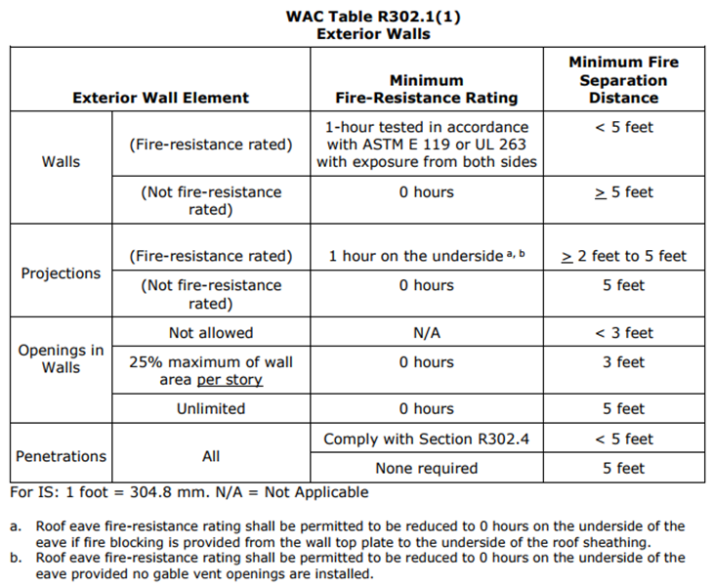

1. Only fencing and condensers may be permitted within minimum side building setback areas. No other permanent structures shall be allowed.
2. Residential Landscape Requirements:

To provide for eventual community tree cover and shading of the pedestrian transportation network, single-family residential units, whether detached, patio home, townhome or twinhome, shall provide the installation and maintenance of a minimum of two hardwood-species canopy trees within each platted lot.

1. One of the required trees shall be placed within 15 feet of the property line adjacent to any public street right-of-way.
2. Minimum size required shall be 3” in caliper measured 1 foot above the root ball.
3. **Supplemental Regulations for Townhouse and Patio Home Developments**
4. Townhouse Requirements

(a) *Building setbacks.*

1. *Front yard.* The minimum front yard setback shall be 20 feet. However, if all off-street parking is located in the rear of the dwelling unit and no curb cuts are provided on the front (street side), then the front yard setback may be reduced to 15 feet.

1. *Side yard.* The minimum side yard setback shall be ten feet on lots siding on alleys. The minimum side yard setback on corner lots shall be 15 feet on minor streets, 20 feet on secondary and collector streets, and 25 feet on arterial streets. There shall be a minimum of ten feet of unobstructed distance between any townhouse group consisting of contiguous dwelling units.
2. *Rear yard.* The minimum rear yard setback shall be 20 feet. However, if off-street parking is located on the front (street side), then the rear yard setback may be reduced to ten feet.
3. *Common courts.* Where townhouse lots and dwelling units are designed to face an open or common court rather than upon a public street, then said open or common court shall be at least 40 feet wide and not more than 200 feet long, measured from the public street to which said court must open. Said court may not include vehicular drives or parking area in front of dwelling units.

(b) *Lots.*

1. *Area.* Lot area shall be a minimum of 2,500 square feet.
2. *Width.* Lot width shall be a minimum of 25 feet.
3. *Depth.* Lot depth shall be a minimum of 100 feet
4. *Corner lot.* Corner lots shall have a minimum width of ten feet greater than interior lots.
5. *Streets.* All townhouse subdivisions shall have a direct access street to at least one dedicated and accessible public street having a right-of-way width of not less than 50 feet. Alleys, where used, shall have a minimum right-of-way of 20 feet and shall be developed with a concrete pavement in accordance with city construction standards.
6. Townhouse groupings. Townhouse groupings shall not exceed a length of more than 300 feet for any one group.
7. Patio Home Requirements
8. *Building setback lines.*
9. *Front yard.* The minimum front yard setback shall be 20 feet. However, if all off-street parking is located in the rear of the dwelling unit and no curb cuts are provided on the front (street side), then the front yard setback may be reduced to 15 feet.
10. *Side yard.* The minimum side yard setback shall be ten feet on lots siding on alleys. Patio homes must be constructed at least ten feet from one side lot line. The minimum side yard setback on corner lots shall be 15 feet on minor streets, 20 feet on secondary or collector streets, and 25 feet on arterial streets.
11. *Rear yard.* The minimum rear yard setback shall be 20 feet. However, if off-street parking is located on the front side (street side), then the rear yard setback may be reduced to ten feet.
12. *Common courts.* Where patio home lots and dwelling units are designed to face an open or common court rather than a public street, then said open or common court shall be at least 40 feet wide and no more than 200 feet long, measured from the public street to which said court must open. Said court may not include vehicular drives or parking area in front of dwelling units.
13. *Lots.*

1. *Area.* Lot area shall be a minimum of 3,600 square feet.
2. *Width.* Lot width shall be a minimum of 36 feet.
3. *Depth.* Lot depth shall be a minimum of 100 feet.
4. *Corner lot.* Corner lots shall have a minimum width of ten feet greater than interior lots.
5. *Access.* All patio home developments shall have a direct access street to at least one dedicated and accessible public street having a right-of-way width of not less than 50 feet.
6. *Alleys.* Where used, alleys shall have a minimum right-of-way of 20 feet and shall be developed with a concrete pavement in accordance with city construction standards.